**Prize Draw 2015**

To be drawn on 30th October at the Black Bull Pub, Balsham at the Halloween Evening. Tickets 50p each, £5 for a book of 10.

Prizes include a weekend in Paris, flight around Cambridgeshire and a Go Karting experience. Click here to see a full list of prizes

[Add in Prize Draw tab which lists prizes]

**Fundraising**

We are raising money to replace our existing hut. Our first target is £35,000 which will allow us to apply for grants. The total we need is £75,000.

[Add in text and graphic from the newsletter]

[Add in a button to download PDF of newsletter]



**Scouts**

Meet Monday Evening 7.30 - 9.00

Contact:

Paul Carter, Scout Leader

Email: psc_sjk@paulsarah.fsnet.co.uk

**Cubs**

Meet Wednesday Evening 6.30 - 8.00

Contact:

Debbie Mower, Cub Scout Leader

Email: debbie.mower@gmail.com

Balsham Scout Group Headquarters

Woodhall Lane

Balsham

Cambridgeshire

CB21 4EP

Balsham Scout Group

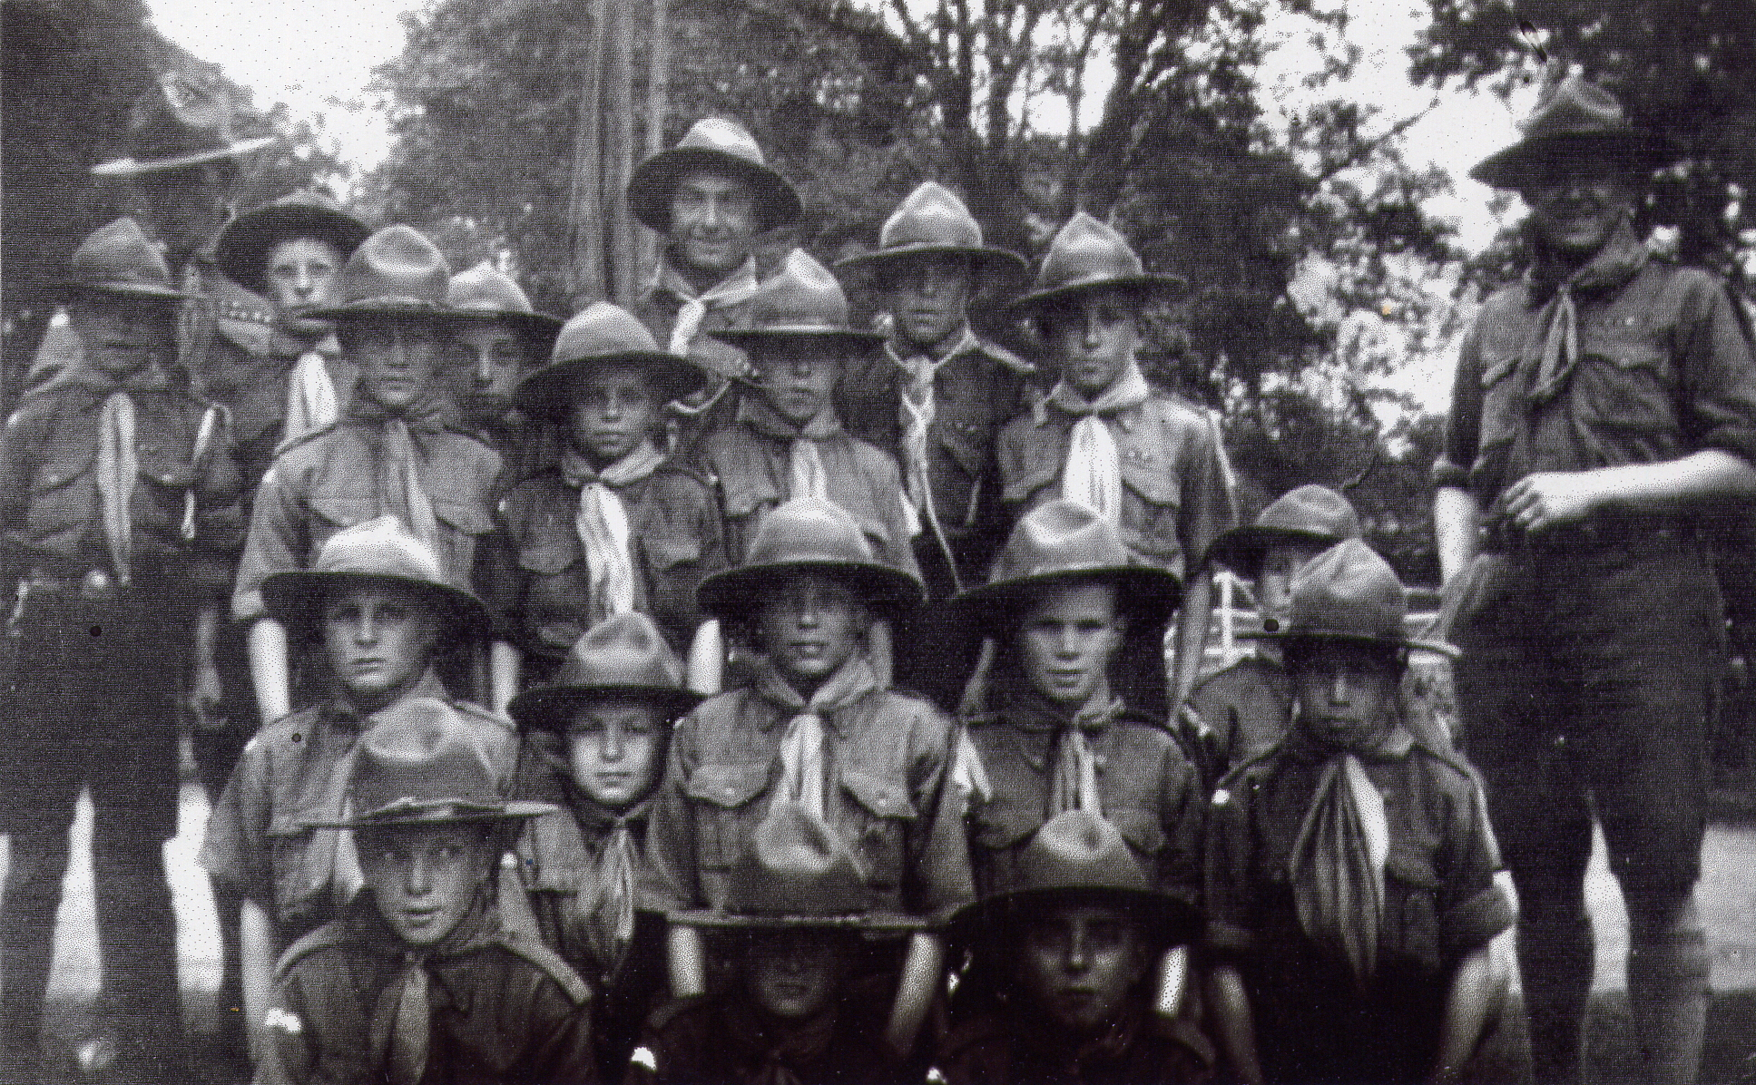

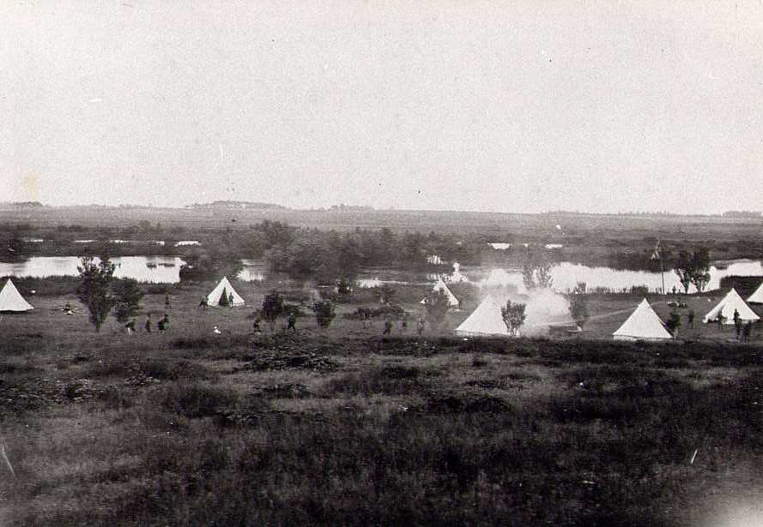

Extra photos that could be used:

Current scout hut

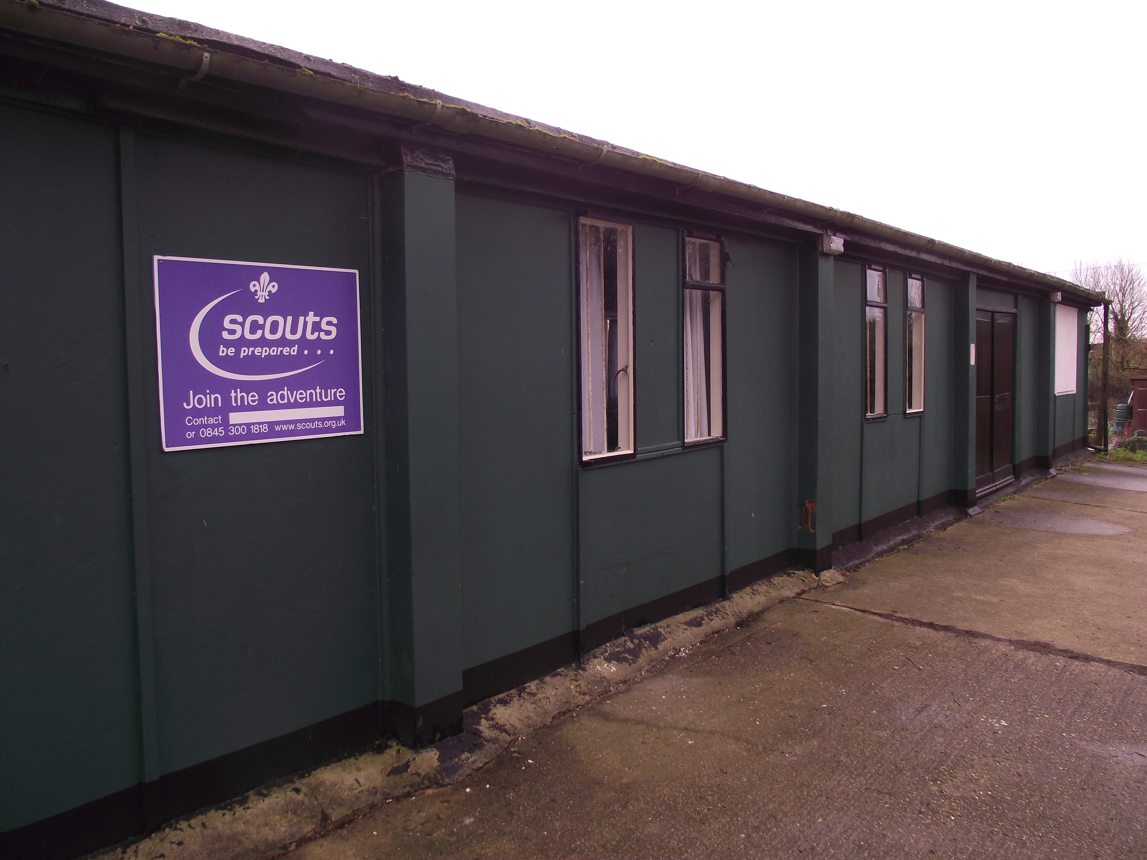

Inside the scout hut

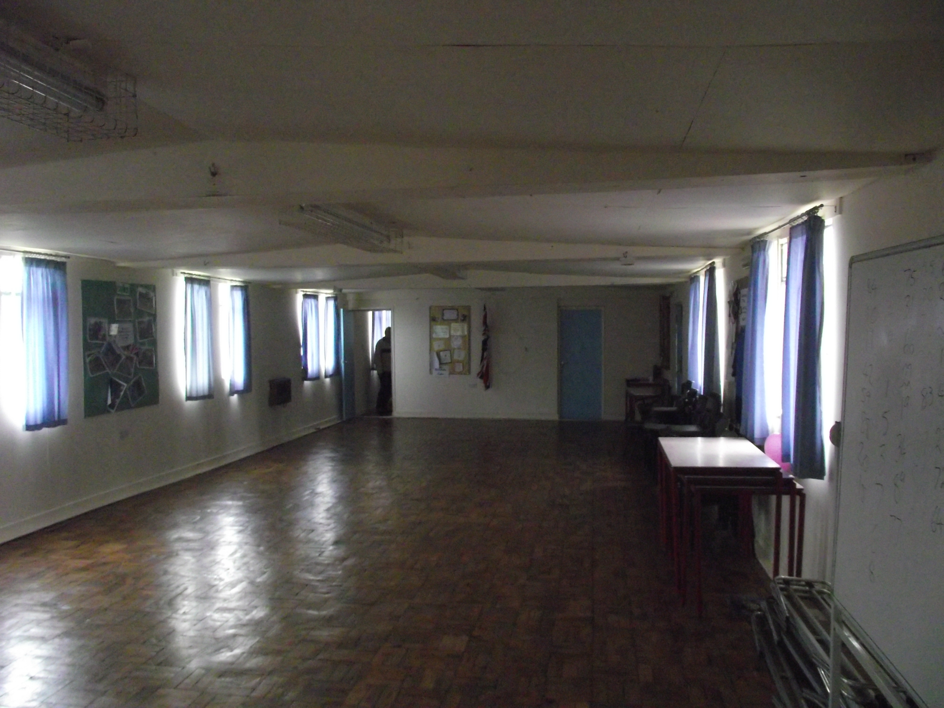

The first scouts in Balsham were over 100 years ago!

